Name_____________________ Period Score ______ / 20

**Atomic Structure Game Activity**

**Team selection**

Form two teams of 2-4 members for each game board. (2 vs 2 is ideal),

Team A Team B

__________________________________ ____________________________________

__________________________________ ____________________________________

__________________________________ ____________________________________

__________________________________ ____________________________________

**Board Preparation**

1. Obtain a set of spin up and spin down s, p and d subshells. Cut out and tape to appropriate location on the game board as shown. (if needed)

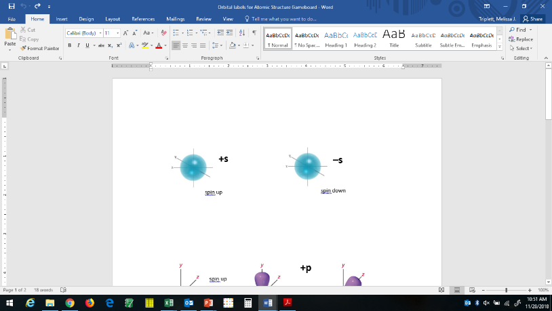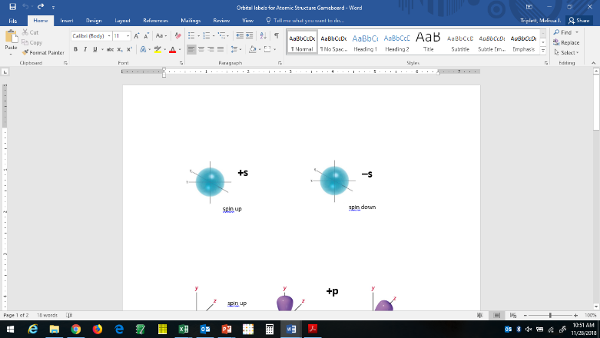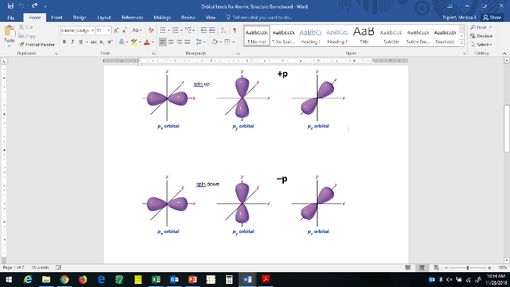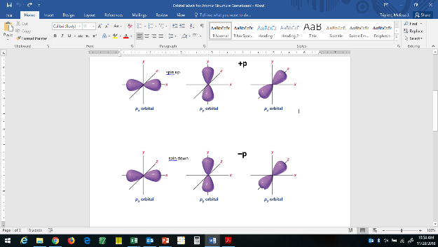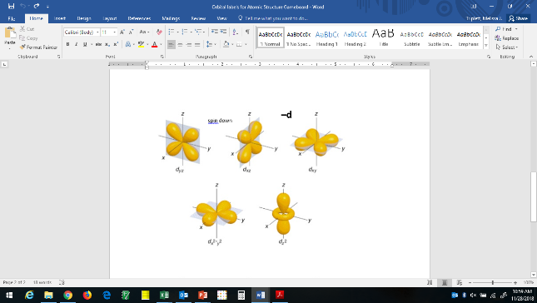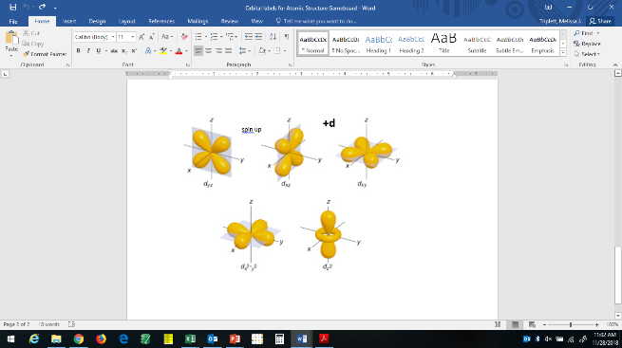

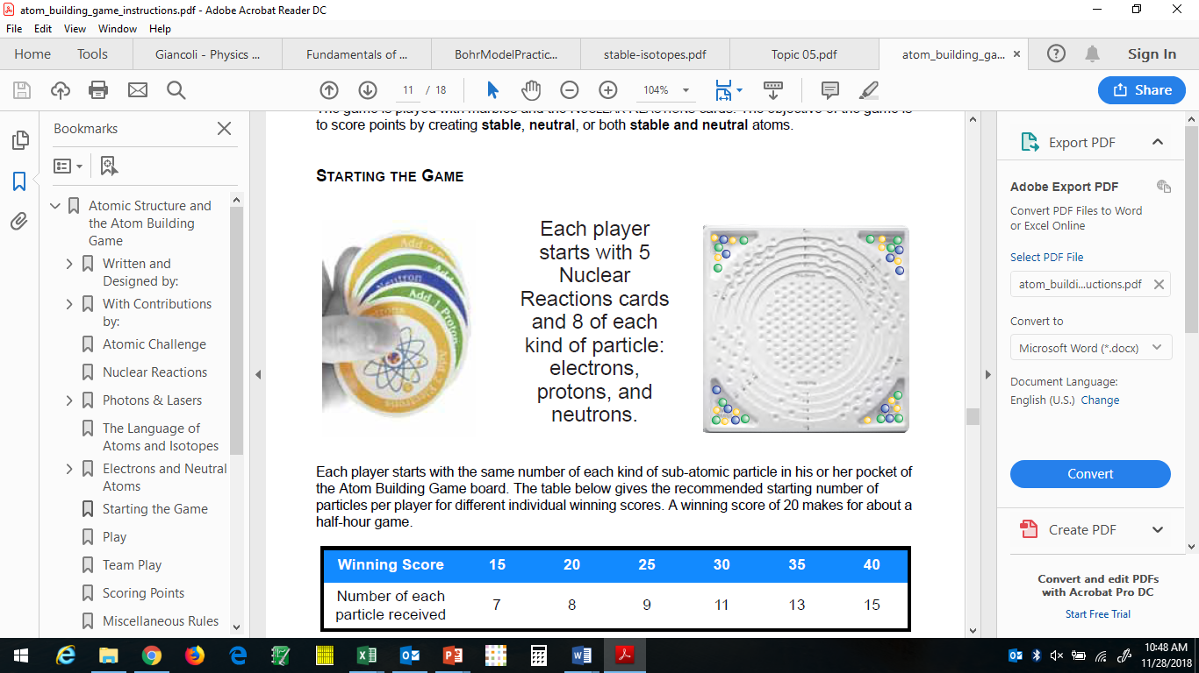

Blue marbles =

Protons

Yellow marbles =

Electrons

Green marbles =

Neutrons

2. What is the atomic number of the largest atom that can be modeled using this game board? _______ What is the name of this element? ____________________

3. Work together to use the game board to represent the Chromium-53 atom:

a) Write the electron configuration for Cr-53.

b) Record your marble locations using the diagram below by darkening in the appropriate arrows. An up white arrow represents an open spin up electron position. A down white arrow represents an open spin down electron position. A colored in arrow represents a filled position.

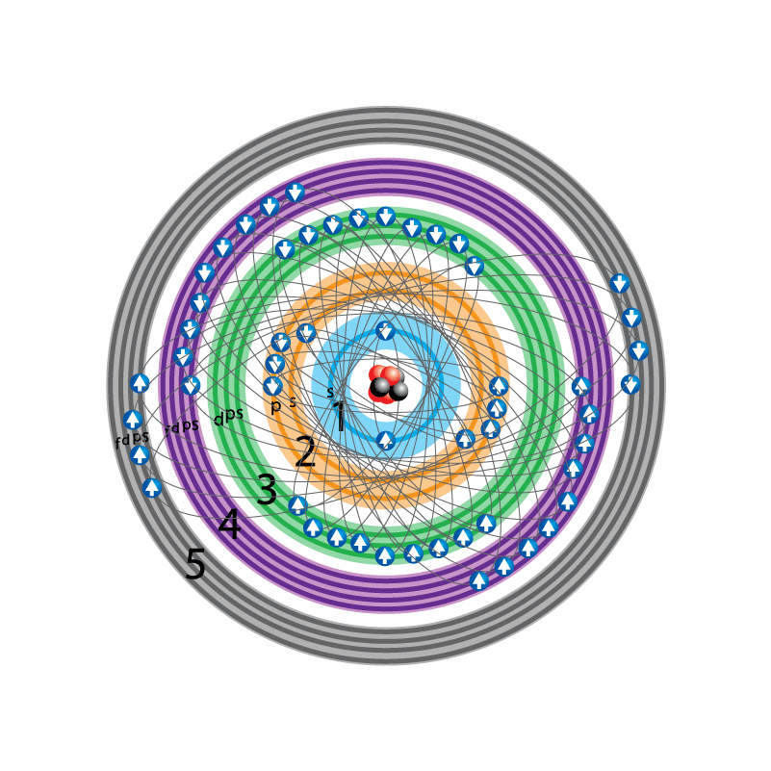

Number of neutrons: _____ Number of Protons: _____

c) How does your model of Cr-53 demonstrate the Pauli Exclusion Principle? (How many marbles can be located in each hole?)

d) How does your model of Cr-53 demonstrate the Aufbau principle? (What order do you place electron marbles?)

e) How does your model of Cr-53 demonstrate Hund’s Rule? (What pattern do you use when filling up a subshell on the board?)

f) How does your model of Cr-53 demonstrate neutrality? (Which color marbles must equal?)

g) Is Cr-53 a stable nucleus? (To determine stability, locate Cr on isotope periodic table. See if #p+#n total is listed for that element.)

**Game Play**

**Set up the board to represent Carbon-12**. **Deal 5 nuclear reaction cards** to each team. Flip a coin (or card) to determine which team plays first on the first game, then alternate who goes first. A turn consists of a team **playing three cards** and applying the cards to the model.

1 point is scored if the resulting atom has a stable nucleus. (#p+#n = isotope on periodic table; #p determines the element)

1 point is scored if the resulting atom is neutral. (#p = #e)

3 points are scored if the resulting atom is both stable and neutral.

1 point is scored *by the opposing team* if they catch you violating the Aufbau principle or Hund’s Rule.

Use the periodic table of stable isotopes to help you determine scores.

After scoring, discard the three cards used. Draw three cards to replace the ones played. If the deck of nuclear reaction cards is used up, reshuffle the discard pile and continue.

Document the turn on the score card. Each team completes a score card for each game. Hand in your score cards at the end of class.

**After 16 turns,** the team with the higher score **wins and receives 2 pts extra** for each team member. If it is a tie, both teams receive 1 pt extra for completing the game.

(**Any game can be cut short** after an even turn if needed. The team with the greater score at this time is the **winner and receives 1 pt extra** for each team member. If it’s a tie, no extra points awarded.)

Play as many games as you can for the time remaining. One member of each team should attach the score cards to their activity.

**Using the Score Card: (Each team completes one score card.)**

For each turn of the game, record the number of protons, electrons and neutrons present at the end of the turn. Identify the isotope represented. State whether the isotope is stable, and/or neutral. Award points to the active team for scoring this turn. If the inactive team catches an Aufbau error or a Hund’s rule error, this should be marked on the score card for the offending turn. The inactive team can score up to two points this way. Record each team’s score at the end of the turn.

Game #___ Team ___ goes first.

|  |  |  |  |  |  |  |  |  |  |  |
| --- | --- | --- | --- | --- | --- | --- | --- | --- | --- | --- |
| Turn | #p | #e | #n | Isotope | Stable? | Neutral? If no, give charge. | Team A Score | Team B Score | AufBau | Hund’s |
| Start | 6 | 6 | 6 | C - 12 | Y | Y | 0 | 0 |  |  |

Questions:

1. For the left image of a neutral atom shown below, a) write the complete electron configuration. b) Then identify the element represented.





2. a) On the image on the right, indicate the marbles you would use to model Ni2+. b) What neutral atom is isoelectronic (has the same electron configuration) with Ni2+?

3. Write the complete electron configuration for the following elements.

a) Germanium

b) Bromine

c) Manganese

4. Write the complete electron configuration for the following ions.

a) S2-

b) Fe3+

5. a) Are the following electron distributions correct with respect to the Aufbau Principle and Hund’s Rule? If not, describe how they should be corrected. b) Identify the neutral atom.







